Static Website Deployment from S3
Objective: To deploy a static website using Amazon S3 and make it accessible over the internet.
Step-1 Sign in to AWS Console
- Go to https://aws.amazon.com and sign in to your AWS Management Console.
- Click on the S3 service .From the S3 dashboard click on “Create Bucket”.
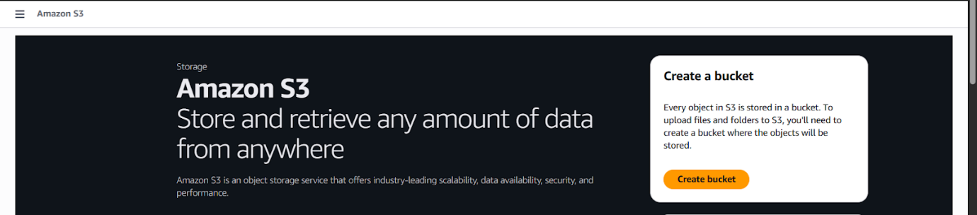
Step-2 Configure Bucket Name
On the S3 dashboard, click on "Create Bucket". Enter a unique Bucket Name (must be globally unique).
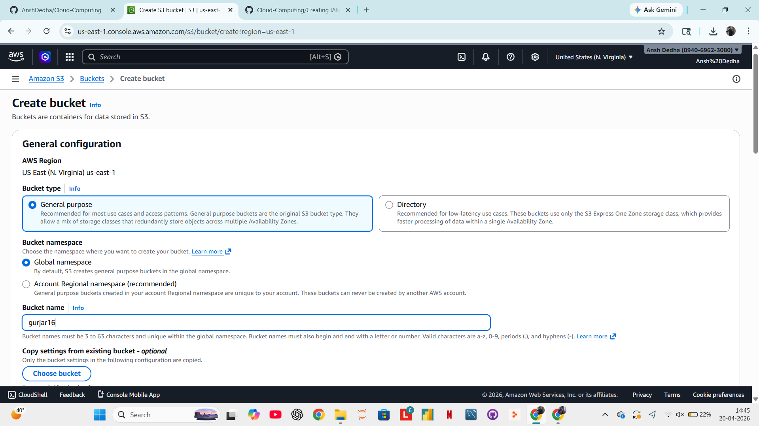
Step3 - Configure Object Ownership
- Under Object Ownership, select "ACLs enabled".
- Choose "Object Writer" so the uploading account owns the object.

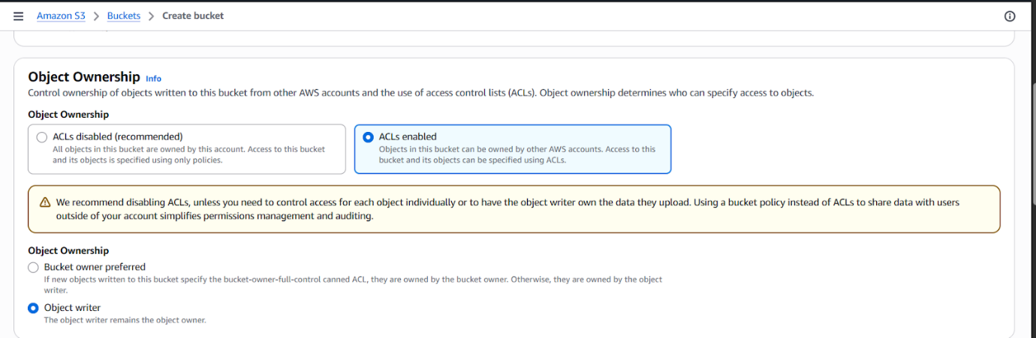
Step 4 - Disable Block Public Access
- Under Block Public Access settings, uncheck the option "Block all public access".
A warning prompt will appear — type "confirm" to acknowledge that the bucket will be publicly accessible
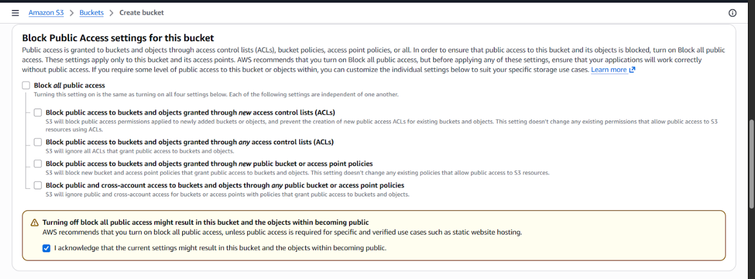
Step 5 — Leave Other Settings as Default than scrool down and click on “Create Bucket”.

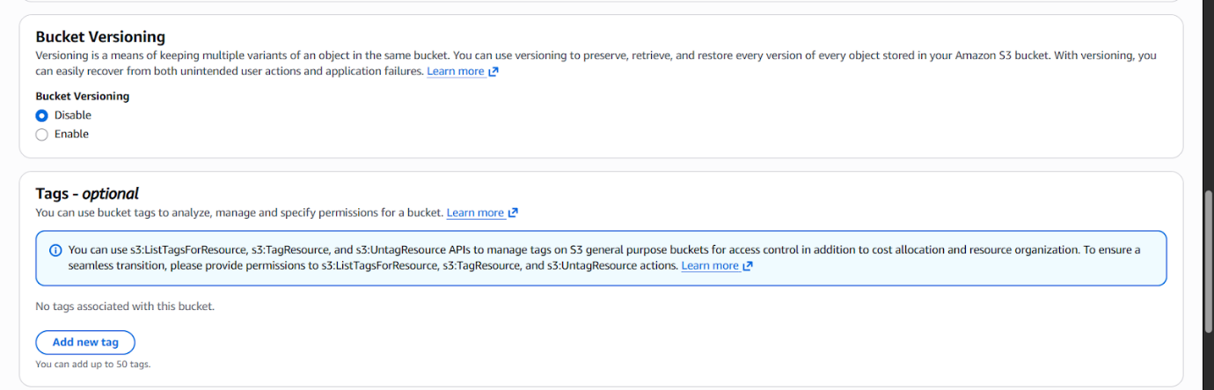
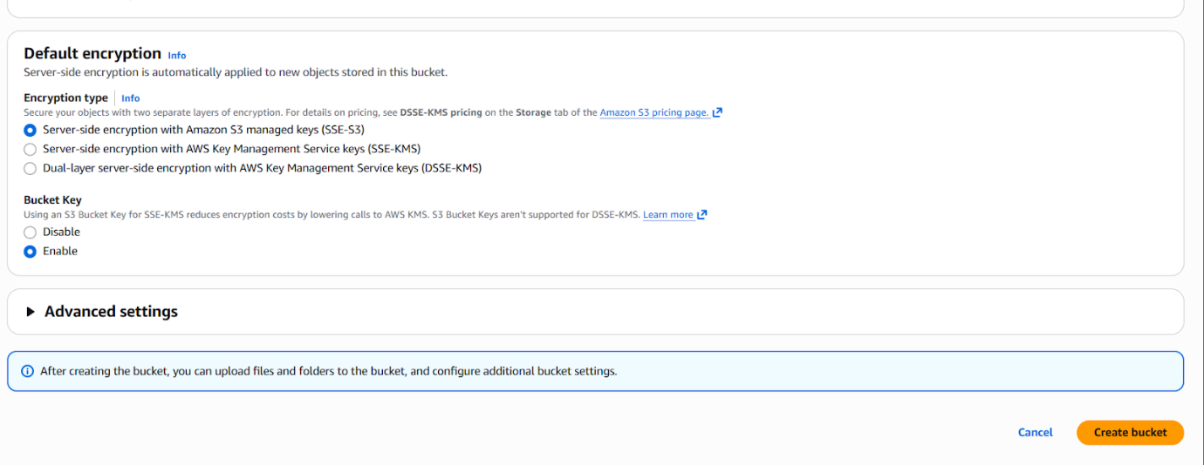
Step-6 Add an Object to the Bucket.
- Click on “Upload”. Click “Add Files” and select the file you want from your device. Leave permission as default(private).
- Click “Upload” to add the object to the bucket
- 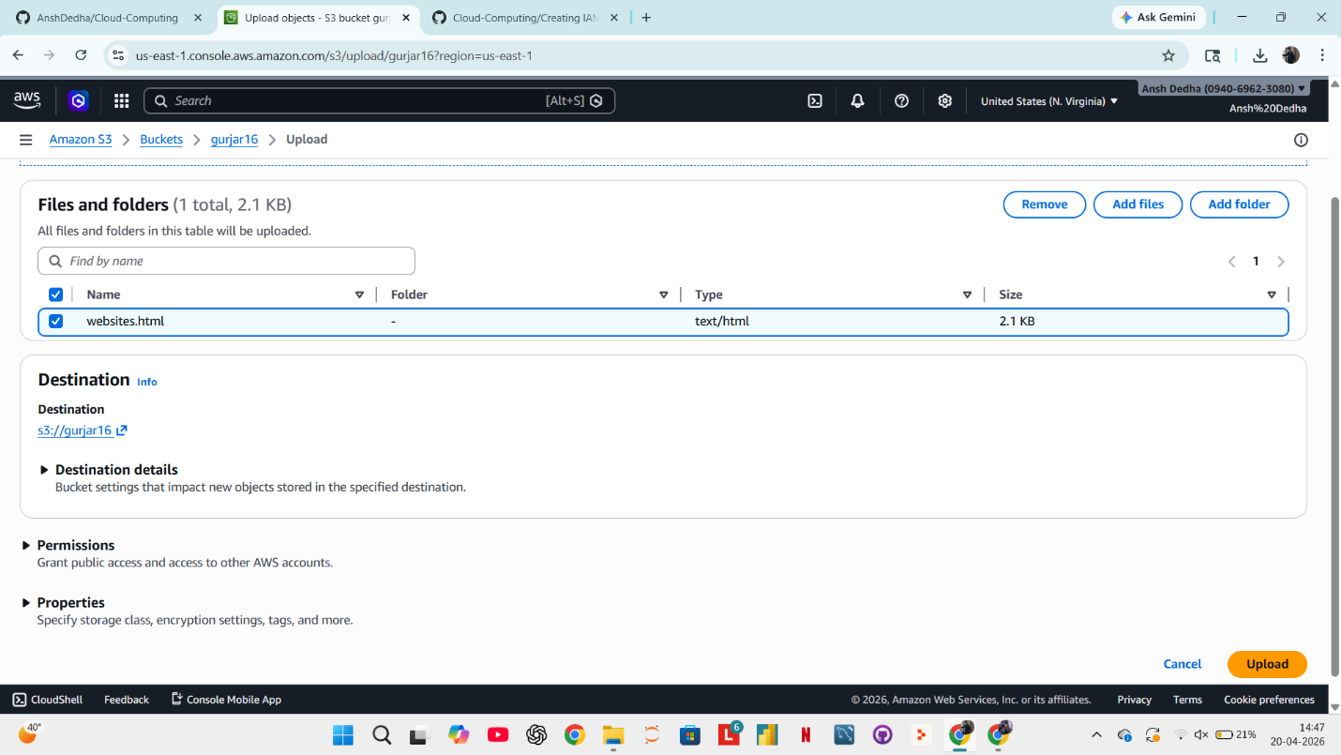

Step-7: Make Object Public
- After uploading, go to the Objects section in your bucket
- Select the uploaded file (e.g., index.html)
- Click on Actions → Make Public using ACL
- Confirm to allow public access
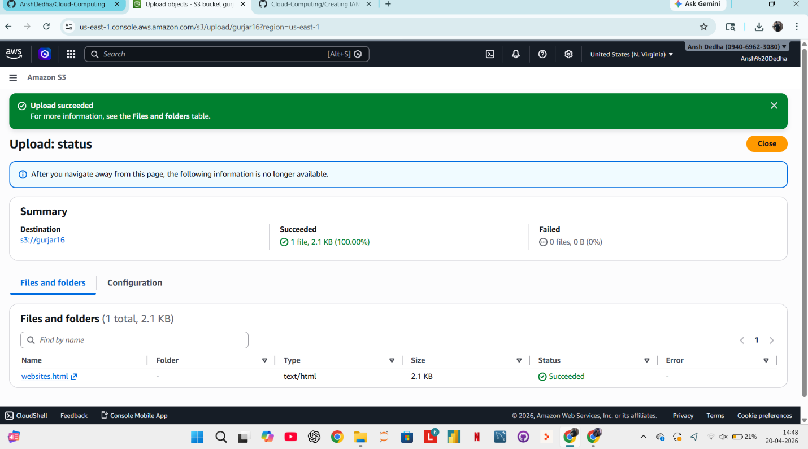
Step-8 Verify: Public Access Successfully Applied
